## Chapter -1

## INTRODUCTION

## INTRODUCTION

On-line Exam System is very much important for any Educational Organizations to prepare their students for any exams by saving the time. It will take check the paper and generate mark sheets as well. It will also help the Organization to test the students and develop their skills. But the disadvantages for this system are, it takes a lot of times when you prepare the exam at the first time for usage.

e-Learning exploits interactive technologies and communication systems to improve the learning experience. It has the potential to transform the way we teach and learn across the board. It can raise standards, and widen participation in lifelong learning. It cannot replace teachers and lecturers, but alongside existing methods it can enhance the quality and reach of their teaching, and reduce the time spent on administration. It can enable every learner to achieve his or her potential, and help to build an educational workforce empowered to change. It makes possible a truly ambitious education system for a future learning society.

On the other hand, pressure comes from policy makers, who recognize that “the complexity of the world today requires employees to have extensive knowledge and skills, more than at any other time, to meet the demands of industry and society.” [89] In the light of globalization governments see the necessity for a highly qualified workforce to enable their country to compete as a center of research and technology and as a business location on a global level.

## The effective use of "Learning Point", any Educational Institute or training centers can use it to develop their strategy for arranging the exams, and for getting better results in less time and better understanding.

##### PROBLEM STATEMENT

## Despite heavy investments in software, training, and new institutions, e-learning has up to now failed to affect the transformation of teaching and learning at universities that many have hoped for. Why is this? We see two types of problems as main causes for this state of affairs, namely organizational and technical problems. Both types of issues are frequently interrelated. Many organizational problems stem from the fact that a typical university is not a homogeneous, hierarchical organization but rather a loosely coupled system of semi-autonomous entities. Thus, decision-making with respect to the system as a whole can be difficult, and top-down decisions—such as the introduction of e-learning—are likely to face opposition.

##### BENEFITS OF E-Learning

* [E-Learning is student-centered](https://e-student.org/advantages-of-e-learning/#e-learning-is-student-centered)
* [E-Learning is cost-effective](https://e-student.org/advantages-of-e-learning/#e-learning-is-cost-effective)
* [Individual learning styles](https://e-student.org/advantages-of-e-learning/#individual-learning-styles)
* [Customizable learning environments](https://e-student.org/advantages-of-e-learning/#customizable-learning-environments)
* [E-Learning fully utilizes analytics](https://e-student.org/advantages-of-e-learning/#e-learning-fully-utilizes-analytics)
* [Online learning could solve teacher scarcity](https://e-student.org/advantages-of-e-learning/#online-learning-could-solve-teacher-scarcity)
* [E-Learning is environmentally friendly](https://e-student.org/advantages-of-e-learning/#e-learning-is-environmentally-friendly)
* [No need for textbooks](https://e-student.org/advantages-of-e-learning/#no-need-for-textbooks)
* [Online learning is time-efficient](https://e-student.org/advantages-of-e-learning/#online-learning-is-time-efficient)

##### AIM AND OBJECTIVES

There are certain goals when it comes to eLearning and some of these are to:

* Enhance the quality of learning and teaching
* Meet the learning style or needs of students
* Improve the efficiency and effectiveness
* Improve user-accessibility and time flexibility to engage learners in the learning process

eLearning is vast and an expanding platform with huge prospective in higher education. Since there are many challenges in making eLearning effective, it is important to know how to manage it and access to the resources. Take a minute and just imagine if one is not having the roadmap to guide from start to finish is actually like plunging into eLearning without an effective strategy because learners would be lost in the learning content.

##### PURPOSE

eLearning purpose is important in implementing eLearning as it will help in producing great results if one knows how to use it. The key success of effective eLearning is not only to set goals but to set **the right** goals. Therefore, it is significant to understand the types of different goals and its unique differences because each goal has its own objectives.

Besides, if eLearning is designed and developed without the right goals in mind, it will be a waste of time and money as the problems will need to be addressed again from other perspectives. Therefore, in order to set the right goals from the beginning, one should know the different kinds of goals based on the situation and the learning context. To set the right goals, one can follow a simple technique which is created to understand the deeper context on eLearning.

**PRODUCT DESCRIPTION**

eLearning, or electronic learning, is the delivery of learning and training through digital resources. Although eLearning is based on formalized learning, it is provided through electronic devices such as computers, tablets and even cellular phones that are connected to the internet. This makes it easy for users to learn anytime, anywhere, with few, if any, restrictions.

Basically, eLearning is training, learning, or education delivered online through a computer or any other digital device.

##### SCOPE

This dissertation describes research in the area of e-learning and we have frequently used the term e-learning in chapter 1. However, e-learning is not a well-defined term and means different things to different people.1 Consequently there is a myriad of definitions; the following definition can be regarded as typical and easily to understand.

##### APPLICATIONS

E-learning refers to the use of electronic media and information and communication technologies (ICT) in education. E-Learning is the use of technology to enable people to learn anytime and anywhere. E-Learning can include training, the delivery of just-in-time information and guidance from experts. E-learning includes numerous types of media that deliver text, audio, images, animation, streaming video, audio or video tape, satellite TV, CD or DVD-ROM and computer-based, as well as web-based learning. E-learning can occur in or out of the classroom easy to learn and better platform to learn skill.

## Chapter -2

**SURVERY OF TECHNOLOGIES**

#### SURVERY OF TECHNOLOGIES

##### About Java

JAVA was developed by Sun Microsystems Inc in 1991, later acquired by Oracle Corporation. It was developed by James Gosling and Patrick Naughton. It is a simple programming language.  Writing, compiling and debugging a program is easy in java.  It helps to create modular programs and reusable code.

## Java terminology

Before we start learning Java, lets get familiar with common java terms.

**Java Virtual Machine (JVM)**

This is generally referred as JVM. Before, we discuss about JVM lets see the phases of program execution. Phases are as follows: we write the program, then we compile the program and at last we run the program.  
1) Writing of the program is of course done by java programmer like you and me.  
2) Compilation of program is done by javac compiler, javac is the primary java compiler included in java development kit (JDK). It takes java program as input and generates java bytecode as output.  
3) In third phase, JVM executes the bytecode generated by compiler. This is called program run phase.

So, now that we understood that the primary function of JVM is to execute the bytecode produced by compiler. **Each operating system has different JVM, however the output they produce after execution of bytecode is same across all operating systems**. That is why we call java as platform independent language.

**bytecode**  
As discussed above, javac compiler of JDK compiles the java source code into bytecode so that it can be executed by JVM. The bytecode is saved in a .class file by compiler.

**Java Development Kit(JDK)**

While explaining JVM and bytecode, I have used the term JDK. Let’s discuss about it. As the name suggests this is complete java development kit that includes JRE (Java Runtime Environment), compilers and various tools like JavaDoc, Java debugger etc. In order to create, compile and run Java program you would need JDK installed on your computer.

**Java Runtime Environment(JRE)**

JRE is a part of JDK which means that JDK includes JRE. When you have JRE installed on your system, you can run a java program however you won’t be able to compile it. JRE includes JVM, browser plugins and applets support. When you only need to run a java program on your computer, you would only need JRE.

## Features of JAVA

### Java is a platform independent language:

Compiler(javac) converts source code (.java file) to the byte code(.class file). As mentioned above, JVM executes the bytecode produced by compiler. This byte code can run on any platform such as Windows, Linux, Mac OS etc. Which means a program that is compiled on windows can run on Linux and vice-versa. Each operating system has different JVM, however the output they produce after execution of bytecode is same across all operating systems. That is why we call java as platform independent language.

### Java is an Object Oriented language:

Object oriented programming is a way of organizing programs as collection of objects, each of which represents an instance of a class.

Four main concepts of Object Oriented programming are:

1. Abstraction
2. Encapsulation
3. Inheritance
4. Polymorphism

### Simple:

Java is considered as one of simple language because it does not have complex features like Operator overloading, Multiple Inheritance, pointers and Explicit memory allocation.

### Robust Language:

Robust means reliable. Java programming language is developed in a way that puts a lot of emphasis on early checking for possible errors, that’s why java compiler is able to detect errors that are not easy to detect in other programming languages. The main features of java that makes it robust are garbage collection, Exception Handling and memory allocation.

### Secure:

We don’t have pointers and we cannot access out of bound arrays (you get Array Index Out Of Bounds Exception if you try to do so) in java. That’s why several security flaws like stack corruption or buffer overflow is impossible to exploit in Java.

### Java is distributed:

Using java programming language we can create distributed applications. RMI(Remote Method Invocation) and EJB(Enterprise Java Beans) are used for creating distributed applications in java. In simple words: The java programs can be distributed on more than one systems that are connected to each other using internet connection. Objects on one JVM (java virtual machine) can execute procedures on a remote JVM.

### Multithreading:

Java supports multithreading. Multithreading is a Java feature that allows concurrent execution of two or more parts of a program for maximum utilization of CPU.

### Portable:

As discussed above, java code that is written on one machine can run on another machine. The platform independent byte code can be carried to any platform for execution that makes java code portable.

**Tools Used:**

The Java Development Kit (JDK) is one of three core technology packages used in java programming, along with the JVM (Java Virtual Machine) and the JRE (Java Runtime Environment). It’s important to differentiate between thesethree technologies, as well as understanding how they’re connected:

1. The JVM is the Java platform component the execute programs.
2. The JRE is the on-disk part of java that creates the JVM.
3. The JDK allows developers to create Java program that can be executed and run by the JVM and JRE.

MySQL is a prominent open-source relational database management system. An incredibly flexible and powerful program, MySQL is used to store and retrieve data for a wide variety of popular applications.

**Other Requirements**

The other basic requirement of our project is as follows:

Operating system could be of any version of window a minimum required is window 7.Appropriate knowledge of language that are used in java coding. Apart from the above mentioned software requirements the hardware requirements the software requirements of the project are as the processor must be Intel Pentium dual core or above. The optimized requirement of the RAM is of 1GB.

**Chapter -3**

**MODULES**

**PRODUCT MODULS**

**PRODUCT PERSPECTIVE**

This website is designed for the web-based browsers. There should be an internet connection for appearing these tests. This interface is very easy and can be maintained by anyone. This familiar GUI will make the user feel more comfortable navigating and viewing the data on our system. Once our application is loaded into browser it allows user to give online test and make themselves improved. Online Student

**FEASIBILITY STUDY**

After analyzing the scope of the project, the feasibility study is very essential to be held. It is basically keeping the following points in mind.

**Developing for meeting:** This website has met its scope. As there is no data involved in the system, processing of files.

The processing of this website is very simple as it has been designed in java script and it has been well divided into several functions according to the need.

**ECONOMIC FEASIBILITY**

Economic analysis is most frequently used for evaluation of the effectiveness of the system. More commonly known as cost/benefit analysis the procedure is to determine the benefit and saving that are expected from a system and compare them with costs, decisions is made to design and implement the system.

**BEHAVIOURAL FEASIBILITY**

People are inherently resistant to change and computer has been known to facilitate changes. An estimate should be made of how strong the user is likely to move towards the development of computerized system. These are various levels of users in order to ensure proper authentication and authorization and security of sensitive data of the organization.

**Technically feasible:** This website is very much technically feasible. This website is very much concerned with specifying equipment and the website will successfully satisfy almost all the user’s requirements. The technical need for this system may vary considerably but might include:

a. The facility to produce report instantly after finishing exam.

b. Response time under certain conditions.

c. Ability to process a file at a particular speed.

Therefore, the basic input/output of all files is identified. So, the project can easily be build up and it will also be technically feasible.

**State of Art:** The project is very much within the state of art since the project is a WINDOWS based; it uses very modern and common technique. Online Student Test 5

Beside it is very much modern and user friendly. It also works as middleware i.e. only in between the user and the file. So, it is completely a state of art project.

**Resources:** As motioned earlier that the resources are easily available and the cost of training is almost negligible. Sometimes situations may arise when it may not be so much easy. For a person completely unaware of using a computer system could result in a training cost or for a very small organization the purchase of a computer, instalment of the system and other charges may lead to a difficult matter.

**Touching User’s mind:** The basic features of this software are simplicity, easily understandable, easily applicable. If this type of software is a new experience for the user is certainly going to be like it.

## Chapter -4

**FUNCTIONAL &NON FUNCTIONAL**

**Software Requirement**

1. MY SQL: It is a relational database management system. As a database it‘s a software product whose primary function is to store & retrieve data as requested by other software applications, be it those on the same computer or those running on another computer across a network (including the internet).
2. J2EE 8: Jsp or Java Server page is a server-side technology; Java Server Pages are an extension to the Java servlet technology that was developed by Sun. JSPs have dynamic scripting capability that works in tandem with HTML code.MVC is latest architecture we used in our project for better coding and debugging. Model is our database View is jsp and controller is servlet i.e. bean.
3. Netbeans 8: NetBeans is an integrated development environment (IDE) for developing primarily with Java, but also with other languages, in particular PHP, C/C++, and HTML5.[3] It is also an application platform framework for Java desktop applications and others. The NetBeans IDE is written in Java and can run on Windows, OS X, Linux, Solaris and other platforms supporting a compatible JVM.
4. Operating System : Windows, MAC and Other Operating System.
5. Browser: Google chrome latest version, Internet Explorer 10 and Other browser.

**Hardware Requirement**

1. **System :** Pentium IV 2.4 GHz or above.
2. **Hard Disk :**512 Mb minimum.
3. **Monitor :**14’ Colour Monitor.
4. **Mouse :**Optical Mouse.
5. **Ram :**512 Mb.

**Features of Online Student Test**

Easy to register and give test for online exams. It is completely secure. It can be completely controlled by admin. This system is easily compatible with most of the Android Phones and browsers also. It is very interactive and saves time. Reduces paper works. Students will be able to see all the test results and improve their skills.

**Future scope of the work**

The development process of this system can be easily followed by adding new features to this application as the customer can command the application to take answer and submit it. We will add a payment gateway in this project.

## Chapter -5

**Project Category & Working**

**DESIGN**

This phase deals with diagrammatic representation and the flow of operations of the proposed system, which include ER Diagram, Use Case Diagram, Class Diagram, Data Flow Diagram, and Sequence Diagram.

**Use Case Diagram**

In software and systems engineering, a Use Case is a list of actions or event steps, typically defining the interactions between a actor and a system, to achieve a goal. The actor can be a human or other external system. Use case diagrams are typically develop in early stage of development and people often apply use case modeling for the following purposes.

1. Specify the context of a system.
2. Capture the requirements of system.
3. Validate system architecture.
4. Use cases should start off simple and at the highest view possible.
5. Use case diagrams are based upon functionality and thus should focus on the “what” and not “how”.

**Use Case Diagram**

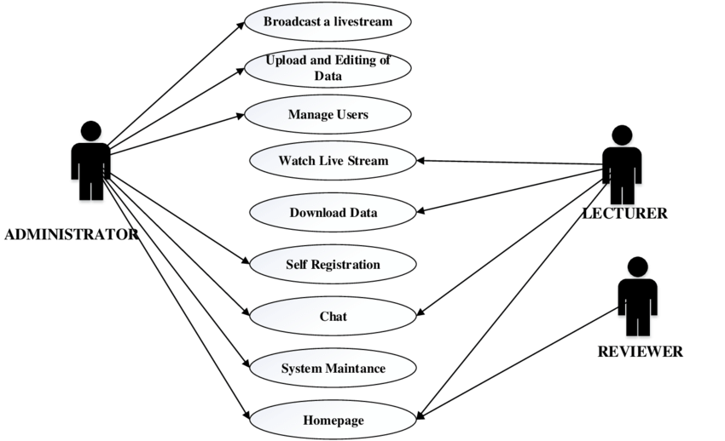

**Fig : Use Case Diagram.**

**Activity Diagram**

Activity diagram is another important diagram in UML to describe the dynamic aspects of the system. Activity diagram is basically a flowchart to represent the flow from one activity to another activity. The activity can be described as an operation of the system. The control flow is drawn from one operation to another. This flow can be sequential, branched, or concurrent. Activity diagrams deal with all type of flow control by using different elements such as fork, join, etc.

**Purpose of Activity Diagram**

1. The basic purposes of activity diagrams are similar to other four diagrams. It captures the dynamic behavior of the system. Other four diagrams are used to show the message flow from one object to another but activity diagram is used to show message flow from one activity to another.
2. Activity is a particular operation of the system. Activity diagrams are not only used for visualizing the dynamic nature of a system, but they are also used to construct the executable system by using forward and reverse engineering techniques. The only missing thing in the activity diagram is the message part.
3. It does not show any message flow from one activity to another. Activity diagram is sometimes considered as the flowchart. Although the diagrams look like a flowchart, they are not. It shows different flows such as parallel, branched, concurrent, and single.

The purpose of an activity diagram can be described as :

1. Draw the activity flow of a system.
2. Describe the sequence from one activity to another.
3. Describe the parallel, branched and concurrent flow of the system.

**Activity Diagram for Student**

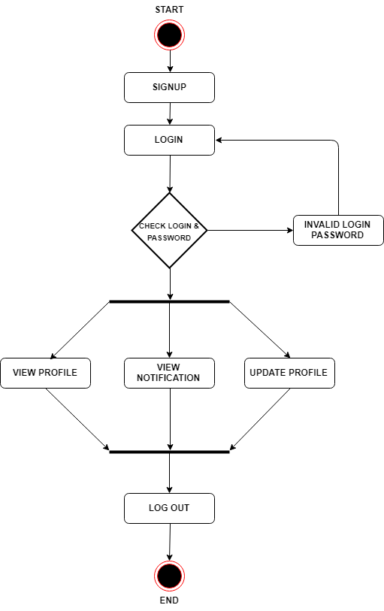

**Fig No 4.2: Activity Diagra**

**Activity Diagram for Admin:**

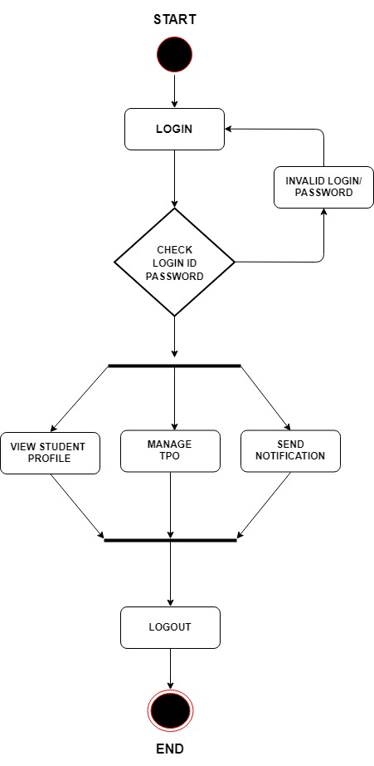

**Fig: Activity Diagram**

**Sequence Diagram**

A sequence diagram is an interaction diagram that shows how objects operate with one another and in what order. It is a construct of a message sequence chart. A sequence diagram shows object interactions arranged in time sequence.

**Benefits of sequence diagrams**

1. Sequence diagrams can be useful references for businesses and other organizations. Try drawing a sequence diagram to:
2. Model the logic of a sophisticated procedure, function, or operation.
3. See how objects and components interact with each other to complete a process.
4. Plan and understand the detailed functionality of an existing or future scenario.



**Fig : Sequence Diagram**

**Class Diagram:**

A class diagram is the description of the relationships and source code dependencies among classes. In this context, a class defines the methods and variables in an object, which is a specific entity in a program or the unit of code representing that entity.

**Benefits Of Class Diagrams:**

Class diagrams offer a number of benefits for any organization. Use UML class diagrams to:

1. Illustrate data models for information systems, no matter how simple or complex.
2. Better understand the general overview of the schematics of an application.
3. Visually express any specific needs of a system and disseminate that information throughout the business.
4. Create detailed charts that highlight any specific code needed to be programmed and implemented to the described structure.
5. Provide an implementation-independent description of types used in a system that are later passed between its components.

**Basic Components Of a Class Diagram:**

1. **Upper section:**Contains the name of the class. This section is always required, whether you are talking about the classifier or an object.
2. **Middle section:**Contains the attributes of the class. Use this section to describe the qualities of the class. This is only required when describing a specific instance of a class.
3. **Bottom section:**Includes class operations (methods). Displayed in list format, each operation takes up its own line. The operations describe how a class interacts with data.

**Member Access Modifiers:**

Private (-)All classes have different access levels depending on the access modifier (visibility). Here are the access levels with their corresponding symbols:

* Public (+)
* Private (-)
* Protected (#)
* Package (~)
* Derived (/)
* Static (underlined)

**Class Diagram**

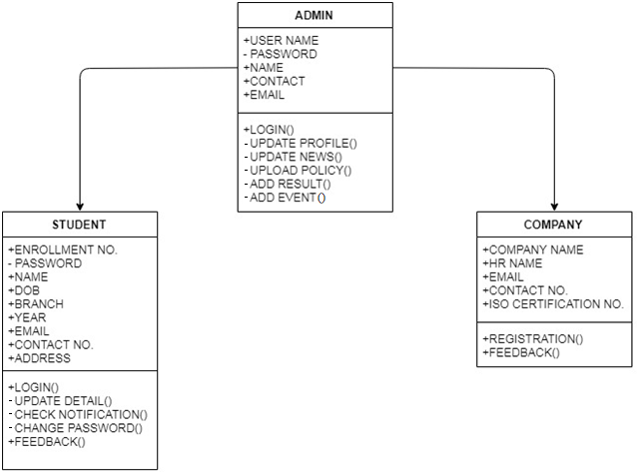

**Fig No 4.6: Class Diagram**

**ER Diagram:**

An entity-relationship diagram (ERD) is a data modeling technique that graphically illustrates the entities and the relationships between those entities. An ERD is a conceptual and representational model of data used to represent the system’s framework infrastructure.

**Conceptual ERD Symbols**

These symbols are generally used for conceptual data models, although some aspects may spill over into logical data models. They can be found in the UML Entity Relationship and Entity Relationship shape library of Lucidchart. If you don't see the shape you need, use an image file (Lucidchart supports .PNG, .JPG, or .SVG import) or create your own with our existing shapes and styling options.

**ENTITIES:**

1. **Strong entities** exist independently from other entity types. They always possess one or more attributes that uniquely distinguish each occurrence of the entity.
2. **Weak entities** depend on some other entity type. They don't possess unique attributes (also known as a primary key) and have no meaning in the diagram without depending on another entity. This other entity is known as the owner.
3. **Associative entities** are entities that associate the instances of one or more entity types. They also contain attributes that are unique to the relationship between those entity instances.

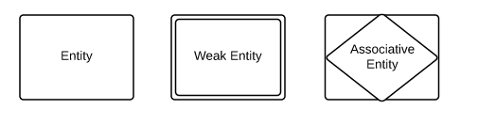

## RELATIONSHIPS

1. **Relationships** are meaningful associations between or among entities. They are usually verbs, e.g. assign, associate, or track. A relationship provides useful information that could not be discerned with just the entity types.
2. **Weak relationships**, or identifying relationships, are connections that exist between a weak entity type and its owner.

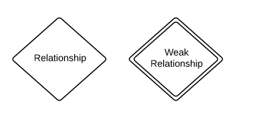

**ATTRIBUTES**

1. **Attributes** are characteristics of either an entity, a many-to-many relationship, or a one-to-one relationship.
2. **Multivalve attributes** are those that are capable of taking on more than one value.
3. **Derived attributes** are attributes whose value can be calculated from related attribute values.

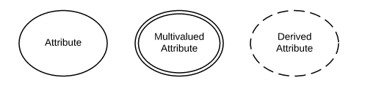

**ER Diagram**



**Fig No 4.7: ER Diagram**

**Data Flow Diagram:**

A **data flow diagram** (**DFD**) is a graphical representation of the "**flow**" of **data** through an information system, modeling its process aspects. A **DFD** is often used as a preliminary step to create an overview of the system without going into great detail, which can later be elaborated.

**Representation of Components:**

DFDs only involve four symbols. They are:

1. Processp
2. Data Object
3. Data Store
4. External entity

|  |  |
| --- | --- |
| http://members.tripod.com/~myyee/cs457/process.gif | 1. **Process** Transform of incoming data flow(s) to outgoing flow(s). |
| http://members.tripod.com/~myyee/cs457/data.gif | 1. **Data Flow** Movement of data in the system. |  |
| http://members.tripod.com/~myyee/cs457/datastore.gif | 1. **Data Store** Data repositories for data that are not moving. It may be as simple as a buffer or a queue or a s sophisticated as a relational database. |  |
| http://members.tripod.com/~myyee/cs457/external.gif | 1. **ExternalEntity** Sources of destinations outside the specified system boundary. |  |

**Strengths and Weaknesses:**

1. **Strengths:**
2. DFDs have diagrams that are easy to understand, check and change data.
3. DFDs help tremendously in depicting information about how an organization operations.
4. They give a very clear and simple look at the organization of the interfaces between an application and the people or other applications that use it.
5. **Weaknesses:**
6. Modification to a data layout in DFDs may cause the entire layout to be changed. This is because the specific changed data will bring different data to units that it accesses. Therefore, evaluation of the possible of the effect of the modification must be considered first.
7. The number of units in a DFD in a large application is high. Therefore, maintenance is harder, more costly and error prone. This is because the ability to access the data is passed explicitly from one component to the other. This is why changes are impractical to be made on DFDs especially in large system.

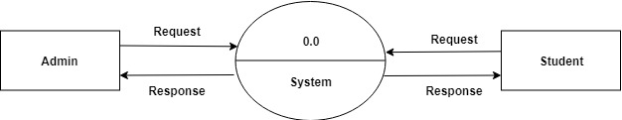

**Fig No 4.8: Data Flow Diagram Level 0**

**For Student**

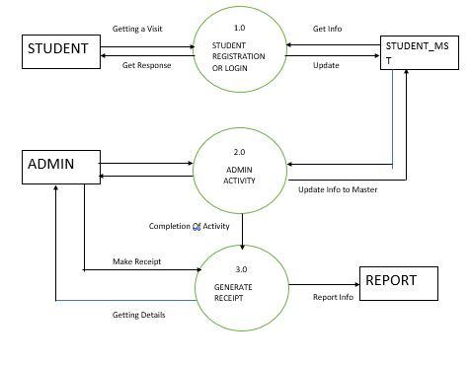

**Fig No 4.9: Data Flow Diagram Level 1 For Student**

**IMPLEMENTATION & TESTING**

**Implementation**

Implementation is the stage of the project when the theoretical design is turned out into working system. Thus it can be considered to be the most critical stage in achieving a successful new system and in giving the user, confidence that the new system will work and be effective. The implementation stage involves careful planning, investigation of the existing system and it’s constraints on implementation, designing of methods to achieve changeover and evaluation of changeover methods.

**Testing**

he purpose of testing is to discover errors. Testing is the process of trying to discover every conceivable fault or weakness in a work product. It provides a way to check the functionality of components, sub assemblies, assemblies and/or a finished product It is the process of exercising software with the intent of ensuring that the Software system meets its requirements and user expectations and does not fail in an unacceptable manner. There are various types of test. Each test type addresses a specific testing requirement.

**Types of Testing**

1. **Unit Testing**

Unit testing involves the design of test cases that validate that the internal program logic is functioning properly, and that program inputs produce valid outputs. All decision branches and internal code flow should be validated. It is the testing of individual software units ofthe application .it is done after the completion of an individual unit before integration. This is a structural testing, that relies on knowledge of its construction and is invasive. Unit tests perform basic tests at component level and test a specific business process, application, and/or system configuration. Unit tests ensure that each unique path of a business process performs accurately to the documented specifications and contains clearly defined inputs and expected result.

**2. Integration Testing**

Integration tests are designed to test integrated software components to determine if they actually run as one program. Testing is event driven and is more concerned with the basic outcome of screens or fields. Integration tests demonstrate that although the components were individually satisfaction, as shown by successfully unit testing, the combination of components is correct and consistent. Integration testing is specifically aimed at exposing the problems that arise from the combination of components.

1. **Functional Testing**

Functional tests provide systematic demonstrations that functions tested are available as specified by the business and technical requirements, system documentation, and user manuals.

Functional testing is centered on the following items:

Valid Input : identified classes of valid input must be accepted.

Invalid Input : identified classes of invalid input must be rejected.

Functions : identified functions must be exercised.

Output : identified classes of application outputs must be exercised.

Organization and preparation of functional tests is focused on requirements, key functions, or special test cases. In addition, systematic coverage pertaining to identify Business process flows; data fields, predefined processes, and successive processes must be considered for testing. Before functional testing is complete, additional tests are identified and the effective value of current tests is determined.

1. **System Test**

System testing ensures that the entire integrated software system meets requirements. It tests a configuration to ensure known and predictable results. An example of system testing is the configuration oriented system integration test. System testing is based on process descriptions and flows, emphasizing pre-driven process links and integration points.

1. **White Box Testing**

White Box Testing is a testing in which in which the software tester has knowledge of the inner workings, structure and language of the software, or at least its purpose. It is purpose. It is used to test areas that cannot be reached from a black box level.

1. **Black Box Testing**

Black Box Testing is testing the software without any knowledge of the inner workings, structure or language of the module being tested. Black box tests, as most other kinds of tests, must be written from a definitive source document, such as specification or requirements document, such as specification or requirements document. It is a testing in which the software under test is treated, as a black box .you cannot “see” into it. The test provides inputs and responds to outputs without considering how the software works.

## Chapter -6

**CONCLUSION**

#### CONCLUSION

This project will develop the knowledge and skill of students. It also saves paper work and saves the time. Students and parent as well will notify with email also about the marks. If the student is scoring good with his or her exam he or she will be upgraded to the next level otherwise he or she will be downgraded. Students or parent can check the best school or colleges or universities around all over India. Every student scored record will be stored and they can see it in a Bar-Graph.

**REFERENCE**

1. www.google.com
2. www.student tutoria.com
3. www.w3school.com
4. www.stack overflow.com
5. www.roseindia.net
6. https://youtube code grid
7. https://youtube coding flag
8. http://www.wikipedia.com
9. http://www.Draw.io.com